Assigment No 14

1) Write a command that puts the following values,
in their given order, into the salespeople table:
city – San Jose, name – Blanco, comm – NULL, cnum
– 1100.
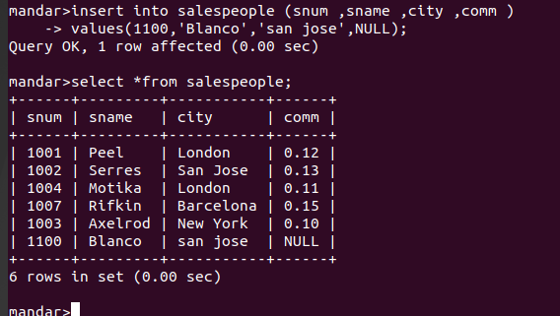

2) Write a command that removes all orders from
customer Clemens from the Orders table.

3) Write a command that increases the rating of
all customers in Rome by 100.
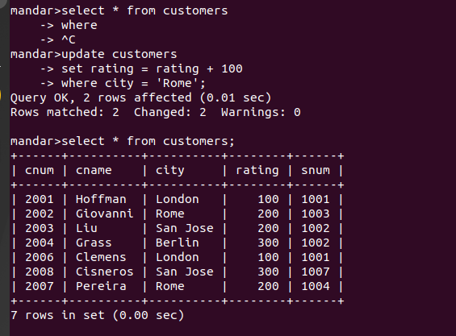

4) Salesperson Serres has left the company.Assign
her customers to Motika.

